🌦️ End-to-End Weather Data Pipeline using OpenWeather API & Databricks

📌 Project Overview
This project demonstrates an end-to-end data engineering pipeline built using the Medallion Architecture (Bronze, Silver, Gold).
Weather data is ingested from the OpenWeather API, processed using PySpark in Databricks, and stored as Delta tables for analytics.

⚙️ Tech Stack
- Databricks (Community / Free Edition)
- PySpark
- Delta Lake
- Python (requests, json)
- OpenWeather API

1️⃣ Architecture & Storage
• OpenWeather API as external source (real-time ingestion)
• Databricks managed tables for storage (no path dependency in free edition)
• Medallion Architecture: Bronze → Silver → Gold
• JSON (raw API response) → Structured Data → Delta Tables
• Partitioning applied on Silver layer (city-based)

2️⃣ Data Engineering
• JSON parsing using predefined schema (StructType)
• Flattening nested data (weather array, main struct)
• Deduplication using (city, timestamp)
• Timestamp conversion (epoch → readable format)
• Data enrichment (event_time, ingestion_time)
• Schema enforcement using Delta Lake
• Partition optimization for query performance

3️⃣ Delta Lake Features
• ACID transactions on all layers
• Time Travel using VERSION AS OF
• Table history tracking using DESCRIBE HISTORY
• Schema enforcement to prevent bad data
• Schema evolution using mergeSchema / overwriteSchema
• Support for UPDATE, DELETE, MERGE operations
• Managed Delta tables using saveAsTable()

4️⃣Orchestration & Workflow
• Separate logical steps:
- API ingestion
- Data transformation (Silver)
- Aggregation (Gold)
• Designed for notebook-based modular execution
• Can be scheduled using Databricks Jobs
• Supports pipeline re-runs with consistent outputs

5️⃣ Data Validation & Quality
• Null checks on critical columns (temperature, city)
• Deduplication validation
• Schema validation during ingestion
• Controlled transformations to ensure consistency

ARCHITECTURE:

Weather API (Raw JSON)
↓
Databricks Bronze (Read-only)
↓
Silver Layer (Cleaned Parquet - Volumes)
↓
Gold Layer (Aggregated Business Tables)
↓
Power BI / Analytics

Medallion Architecture:
Databases/APIs/LOGS/Events -> bronze -> Silver-> Gold ->BI/ML

BRONZE /Raw ingestion:(Used for reprocessing and recovery)
Raw, unprocessed data
Append only
Schema may change
Exact copy of source data

Silver Layer: Clean and refined
Cleaned and validated
Deduplicated records
Standardized formats.
Business logic applied
Joins and enrichments

GOLD LAYER: Analytics ready. (Built for decision making)
Aggregated data
Business-level metrics
Start Schemas
Optimized for Querying

BRONZE: DATA ENGINEERS
SILVER: ANALYTICS ENGINEER AND DATA SCIENTISTS
GOLD: ANALYTICS AND BUSINESS USERS.

SINCE I WAS USING AWS FREE TRAIL AND DATABRICKS FREE EDITION , Incremental loading / Auto loader was not supporting .
✅ FINAL VERIFIED BEHAVIOR (Databricks Free Edition – 2025)
You are correct:
ONLY Volumes are writable in Databricks Free Edition
Everything else is blocked, including:
- ❌ /databricks/driver
- ❌ /tmp
- ❌ dbfs:/
- ❌ Delta tables
- ❌ Streaming sinks
- ❌ Checkpoints
So when you say:
“only volume thing is supporting”

🔑 Step 1: API Key Generation
- Go to OpenWeather
- Sign up and create an account
- Navigate to API Keys section
- Generate a new API key

Created Databricks free edition account.

🔐 Step 2: Secure API Key Storage

import json

with open("/Workspace/Users/harshamhegde7777@gmail.com/API_Data/Data_ingestion/key.json", "r") as f:
config = json.load(f)

api_key = config["api_key"]

# print(config)
print(api_key)

🌐 Step 3: Data Ingestion from API
import requests
import json

cities = [
"Bangalore", "Mumbai", "Delhi", "Hyderabad",
"Chennai", "Kolkata", "Pune", "Ahmedabad",
"Jaipur", "Lucknow"
]

import time

data_list = []

for i in range(10): # run 10 times
for city in cities:
url = f"https://api.openweathermap.org/data/2.5/weather?q={city}&appid={api_key}&units=metric"

response = requests.get(url)
data = response.json()

data_list.append(json.dumps(data))

Converting it to Dataframe and writing to Bronze layer:

df_landing = spark.createDataFrame([(d,) for d in data_list], ["raw_data"])

df_landing.show(truncate=False)

df_landing.printSchema()

df_landing.summary().show()

dbutils.fs.rm("/Volumes/workspace/default/api/landing/", True)

df_landing.write.mode("append").format("delta").save("/Volumes/workspace/default/api/landing/")

🥉 Step 4: Bronze Layer (Raw Data)
df_raw= spark.read.format("delta").load("/Volumes/workspace/default/api/landing/")
df_raw.show()

Defining the schema and parsing the data:

from pyspark.sql.types import *

schema = StructType([
StructField("name", StringType()),
StructField("dt", LongType()),
StructField("main", StructType([
StructField("temp", DoubleType()),
StructField("humidity", IntegerType())
])),
StructField("weather", ArrayType(StructType([
StructField("description", StringType())
])))
])

from pyspark.sql.functions import from_json, col

df_parsed = df_raw.withColumn(
"json_data",
from_json(col("raw_data"), schema)
)

df_parsed.printSchema()

df_clean = df_parsed.select(
col("json_data.name").alias("city"),
col("json_data.main.temp").alias("temperature"),
col("json_data.main.humidity").alias("humidity"),
col("json_data.weather")[0]["description"].alias("weather")
)

display(df_clean)
)

🥈 Step 5: Silver Layer (Data Transformation)

from pyspark.sql.functions import col, from_unixtime, current_timestamp

from pyspark.sql.functions import col, from_unixtime, current_timestamp

from pyspark.sql.functions import from_json, col

df_silver = df_parsed.select(
col("json_data.name").alias("city"),
col("json_data.main.temp").alias("temperature"),
col("json_data.main.humidity").alias("humidity"),
col("json_data.weather")[0]["description"].alias("weather"),
col("json_data.dt").alias("timestamp")
)

df_silver = df_silver.withColumn("event_time", from_unixtime("timestamp")) \
.withColumn("ingestion_time", current_timestamp())

df_silver = df_silver.dropDuplicates(["city", "timestamp"])

display(df_silver)

df_silver.filter(col("temperature").isNull()).count()
df_silver.filter(col("city").isNull()).count()

dbutils.fs.rm("/Volumes/workspace/default/api/processed/", True)

from pyspark.sql.functions import to_date

df_silver = df_silver.withColumn("date", to_date("event_time"))

df_silver.write \
.option("mergeSchema", "true") \
.mode("append") \
.format("delta") \
.save("/Volumes/workspace/default/api/processed/")

🥇 Step 6: Gold Layer (Analytics)
Reading data from Silver layer and performing aggregations / analysis:

df_processed = spark.read.format("delta") \
.load("/Volumes/workspace/default/api/processed/")

display(df_processed)

# ✅ 1. Avg Temperature & Humidity per City

from pyspark.sql.functions import avg

df_gold = df_processed.groupBy("city").agg(
avg("temperature").alias("avg_temperature"),
avg("humidity").alias("avg_humidity")
)

display(df_gold)

# ✅ 2. Latest Weather per City
from pyspark.sql.window import Window
from pyspark.sql.functions import row_number, col

window = Window.partitionBy("city").orderBy(col("event_time").desc())

df_latest = df_processed.withColumn("rank", row_number().over(window)) \
.filter("rank = 1") \
.drop("rank")

display(df_latest)

Writing the Analysed data to Gold layer:

df_gold.write \
.mode("overwrite") \
.format("delta") \
.save("/Volumes/workspace/default/api/curated/weather_agg")

dbutils.fs.rm("/Volumes/workspace/default/api/curated/weather_latest", True)

df_latest.write \
.mode("overwrite") \
.format("delta") \
.save("/Volumes/workspace/default/api/curated/weather_latest")

df_gold.show()
df_latest.show()

Creating Delta table on Gold Aggregations:
Delta Lake provides:
👉 ACID Transactions
👉 Versioning
👉 Data Lineage
👉 Time Travel

df_gold.write \
.mode("overwrite") \
.saveAsTable("weather_gold_agg")

df_latest.write \
.mode("overwrite") \
.saveAsTable("weather_gold_latest")

%sql
DESCRIBE HISTORY weather_gold_agg;
This command shows the full transaction history of a Delta table.
👉 Delta Lake maintains a transaction log (_delta_log)
Every operation (write, update, delete) is recorded as a new version

%sql
SELECT * FROM weather_gold_agg VERSION AS OF 0;
This is called Time Travel in Delta Lake
👉 It allows you to query older versions of data

🔎 What this query does
- Reads data from Version 0
- Ignores all later updates

%sql
SELECT * FROM weather_gold_agg;

This simply reads the latest version of the table
👉 Equivalent to:
VERSION AS OF latest

🔄 Pipeline Orchestration (Databricks Jobs – API Data Pipeline)
The end-to-end API data pipeline is orchestrated using Databricks Jobs, where the workflow is structured into four modular notebooks executed in a defined dependency sequence. This ensures smooth, reliable data flow from ingestion to insights generation.

• Data_Ingestion – Connects to external APIs, handles authentication (API keys/tokens), and ingests raw data into the Bronze layer (stored as JSON in Databricks Volumes)

• Data_Parsing – Parses nested JSON responses, flattens complex structures, handles schema inference, and prepares structured data for downstream processing

• Data_Transformation – Performs data cleaning, deduplication, null handling, data type casting, and business transformations; outputs refined data into the Silver layer using Delta format

• Data_Analysis – Generates aggregations, KPIs, and analytical datasets; prepares Gold layer tables for reporting and visualization (e.g., Power BI)

Snapshots:

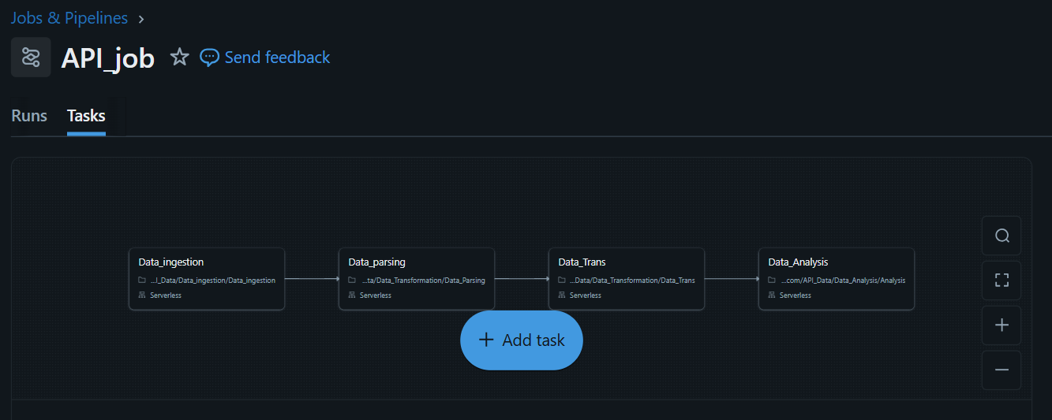

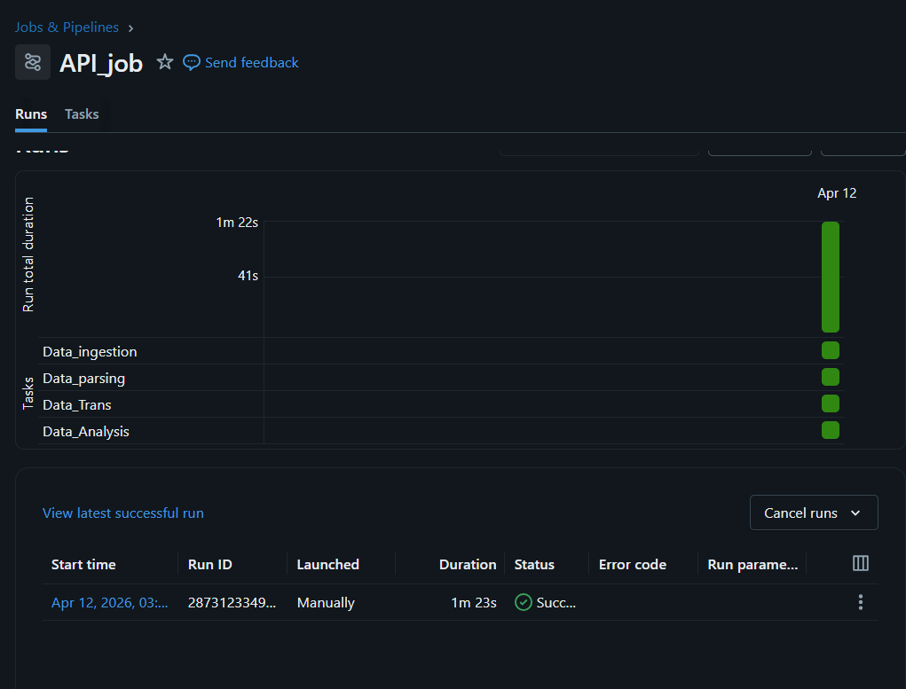
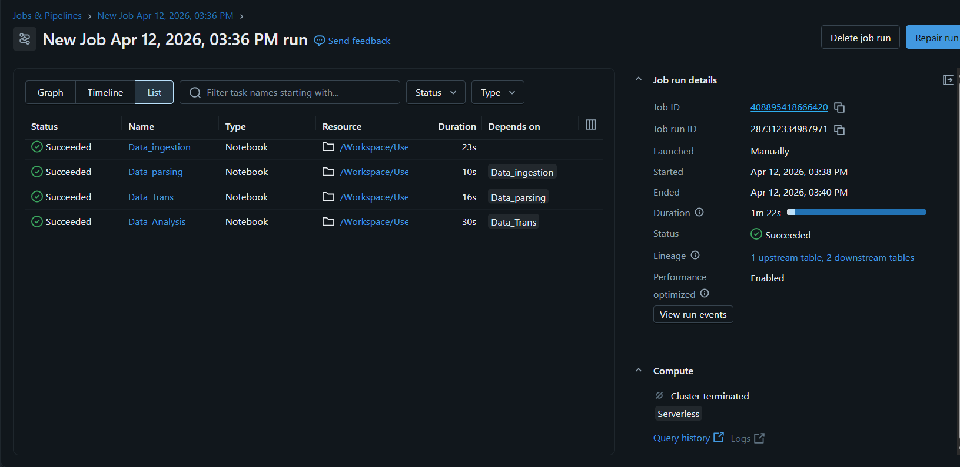

🔮 Future Enhancements
To further strengthen the scalability, reliability, and production readiness of the API-driven data pipeline, the following enhancements can be incorporated:
1️⃣ Incremental & Near Real-Time Data Ingestion
Enhance the ingestion layer by implementing incremental data loading using timestamp-based or watermarking techniques. This minimizes redundant data processing and improves efficiency. Additionally, the pipeline can be extended to support near real-time ingestion using streaming APIs or event-driven architectures.
2️⃣ Robust Error Handling & Retry Mechanisms
Introduce comprehensive error handling to manage API failures such as rate limiting, timeouts, and incomplete responses. Implement automated retry logic, logging mechanisms, and dead-letter handling to ensure no data loss and improved fault tolerance.

3️⃣ Parameterization & Pipeline Reusability
Refactor notebooks to support dynamic parameterization (e.g., API endpoints, date ranges, schema inputs). This enables reusability of the pipeline across multiple data sources and reduces code duplication.
4️⃣ Data Quality & Validation Framework
Integrate a data quality framework to validate data at each stage of the pipeline. This includes checks for null values, duplicates, schema consistency, and data accuracy before promoting data across Bronze, Silver, and Gold layers.
5️⃣ Schema Evolution Handling
Enable schema evolution capabilities to automatically adapt to changes in API response structures. This ensures the pipeline remains resilient to upstream schema changes without manual intervention.
6️⃣ Monitoring, Logging & Alerting
Implement end-to-end monitoring with detailed logging and alerting mechanisms. Integrate notifications (email/Slack) for job failures, SLA breaches, or anomalies, ensuring proactive issue resolution and pipeline observability.
7️⃣ CI/CD & Version Control Integration
Adopt CI/CD practices by integrating with version control systems (e.g., Git). Automate build, test, and deployment processes to enable seamless promotion of code across development, staging, and production environments.

8️⃣ Performance Optimization
Optimize data processing by leveraging partitioning, caching, and efficient join strategies. Apply Delta Lake optimization techniques such as compaction, Z-ordering, and vacuuming to improve query performance and storage efficiency.
9️⃣ Security & Secrets Management
Enhance security by managing API credentials using secure secret scopes instead of hardcoding sensitive information. Implement role-based access control (RBAC) to ensure controlled access to data and resources.
🔟 Data Governance & Lineage
Integrate with centralized governance solutions such as Unity Catalog to enable data lineage tracking, auditing, and improved data discoverability across the organization.
1️⃣1️⃣ Reporting & Visualization Layer
Develop a business intelligence layer on top of Gold datasets using tools like Power BI to deliver actionable insights, dashboards, and KPI reporting to stakeholders.
1️⃣2️⃣ Cost Optimization
Optimize infrastructure usage by leveraging auto-scaling clusters, job clusters, and efficient scheduling. Monitor resource utilization to reduce operational costs while maintaining performance.

📌 CONCLUSION :
End-to-End API Data Pipeline using Databricks
• Designed and implemented a scalable data pipeline following the Bronze–Silver–Gold (Medallion) architecture
• Ingested semi-structured JSON data from external APIs with secure authentication mechanisms
• Parsed and flattened nested API responses into structured formats
• Applied data cleansing, deduplication, and schema standardization
• Performed data transformations to create refined, analysis-ready datasets
• Generated aggregated datasets and KPIs for analytical consumption in the Gold layer
• Orchestrated the pipeline using Databricks Jobs with task-level dependencies
• Implemented validation checks to ensure data quality and consistency
• Ensured reusability and modularity through parameterized, notebook-based design

